INTELLIGENT NOSQL DATABASES
PROJECT REPORT
Smart Mess Food Waste Prediction System: An Intelligent Pre-Meal Waste Forecasting & Kitchen Intelligence System


Submitted by:
[Student Name]
Registration No: [Registration Number]
Programme and Section: B.Tech Computer Science & Engineering
Course Code: CSE-494
Under the Guidance of:
[Faculty Guide Name]
Discipline of CSE/IT
Lovely School of Computer Science and Engineering
Lovely Professional University, Phagwara

TABLE OF CONTENTS
1. Abstract 3
2. Introduction 4
3. Problem Statement 6
4. Objectives 7
5. Dataset Description 8
5.1 Dataset Statistics 9
5.2 Dataset Attributes 10
5.3 Waste Threshold & Label Definition 11
6. Tools and Technologies 12
7. Methodology 14
7.1 Data Loading & Synthesis 14
7.2 Data Cleaning & Validation 14
7.3 Waste Threshold Definition 15
7.4 Exploratory Data Analysis 15
7.5 MongoDB Integration 15
7.6 Zero-Leakage Feature Extraction 16
7.7 Model Training & Optimization 16
7.8 Model Evaluation & Comparison 17
7.9 Model Saving & Full-Stack Deployment 17
8. Data Processing and Exploratory Data Analysis 18
8.1 Data Cleaning & Validation 18
8.2 Waste Level Distribution Analysis 19
8.3 Meal-Type Waste Pattern Analysis 20
8.4 Top 10 Most Wasted Dishes Analysis 21
8.5 Weekday vs. Weekend Turnout & Waste Analysis 22
8.6 Attendance Turnout & Food Efficiency Analysis 23
8.7 Summary of Exploratory Analysis 24
9. MongoDB Integration and CRUD Operations 25
9.1 Database and Collection Creation 25
9.2 Create Operation 26
9.3 Read Operation & Aggregation Pipelines 27
9.4 Update Operation & Metric Recalculation 28
9.5 Delete Operation 29
9.6 CRUD Verification 30
10. Machine Learning Algorithms 31
10.1 Logistic Regression with ColumnTransformer Pipeline 31
10.2 Random Forest Classifier Baseline 32
10.3 Zero-Data-Leakage Expanding Window Feature Pipeline 33
11. Model Evaluation 34
11.1 Evaluation Results 34
11.2 Confusion Matrix Analysis 36
11.3 Feature Importance & Interpretability Analysis 37
11.4 Evaluation Summary 38
12. Results and Discussion 39
12.1 Data Processing Results 39
12.2 MongoDB Database Results 40
12.3 Model Comparison 41
12.4 Class-Level Performance 42
12.5 Confusion Matrix Analysis 43
12.6 Selection of Final Model & Real-World Utility 44
13. Future Enhancements 45
14. Conclusion 46
15. References 47

1. ABSTRACT
Institutional catering facilities, such as university hostel messes, prepare hundreds of kilograms of food daily across scheduled services including Breakfast, Lunch, and Dinner. Historically, kitchen organizers have relied on static guesswork and manual spreadsheets to decide food preparation quantities. This lack of predictive insight causes chronic food waste, financial losses, and environmental harm, or conversely, kitchen deficits where food runs out before all students dine. The Smart Mess Food Waste Prediction System solves this pressing operational problem by combining automated feature validation, an intelligent NoSQL document database, and an interpretable machine learning pipeline to forecast whether an upcoming meal will generate HIGH WASTE (>15.0% leftover ratio) or LOW WASTE (≤15.0% leftover ratio) before cooking begins.
The project utilizes an extensive operational dataset covering 400 continuous days and 1,200 scheduled meal services, spanning 20 authentic Indian hostel dishes (including Poha, Rajma Chawal, Paneer Butter Masala, and Veg Biryani) across 5 culinary categories. The raw operational logs were cleaned, validated for arithmetic weight consistency, and normalized with zero data loss. Binary operational waste labels were assigned based on a 15.0% regulatory waste threshold: 1,079 meals (89.92%) were classified as High Waste and 121 meals (10.08%) as Low Waste, accurately reflecting the real-world challenge of dining hall over-preparation.
The cleaned dataset was integrated into MongoDB (database 'food_waste_db', collection 'meals'), where complete Create, Read, Update, and Delete (CRUD) operations were established and verified using PyMongo. Multi-stage aggregation pipelines ($match, $group, $sort, $unwind) were implemented to compute real-time analytical KPIs, daily waste trajectories, and culinary distributions.
For predictive modeling, a zero-data-leakage historical feature extraction mechanism was designed. When forecasting waste for a meal scheduled at date T, the pipeline queries MongoDB strictly for prior records (t < T) to extract historical dish waste rates, category averages, and weekday turnout patterns. Numerical features were standardized using StandardScaler and categorical variables encoded with OneHotEncoder inside a Scikit-Learn ColumnTransformer pipeline. A Logistic Regression Classifier with balanced class weighting was trained and rigorously evaluated alongside an ensemble Random Forest benchmark on an independent test dataset (240 meals).
Logistic Regression achieved a high Precision of 94.53% for High-Waste alerts and a Recall of 70.83% on Low-Waste meals, with an ROC-AUC score of 68.36%. Furthermore, its interpretable feature coefficients directly reveal the primary operational drivers of leftover food, such as campus fests (+1.3823) and Sunday turnout drops (+0.9479). The system was deployed as a production-ready, dual-tier web application featuring a Node.js Express gateway and Python Flask microservice, demonstrating how NoSQL databases and machine learning can transform institutional kitchen management from reactive waste disposal to proactive waste prevention.

2. INTRODUCTION
Higher education campuses and large residential hostel complexes serve thousands of meals daily across breakfast, lunch, and dinner. Managing institutional food preparation requires a delicate operational balance between student satisfaction, portion availability, budgetary discipline, and environmental stewardship. If a mess kitchen under-prepares food, students face rationing or empty counters, leading to acute dissatisfaction. Consequently, mess supervisors routinely build excessive safety buffers (+10% to +20%) into daily preparation quantities. However, student turnout is highly volatile—heavily influenced by fluctuating academic schedules, weekend leaves, campus cultural festivals, sudden weather changes, and culinary preferences for specific dishes. This chronic over-preparation generates massive amounts of edible food waste that is discarded into municipal landfills, exacerbating institutional operating costs and greenhouse gas emissions.
Traditional hostel mess administration relies on paper logbooks or static spreadsheet entries that record transactions retrospectively. While retrospective accounting can tally how many kilograms of food were discarded after a meal has finished, it provides zero proactive intelligence before preparation begins. Moreover, human kitchen organizers cannot mentally correlate multivariate historical factors—such as how a sudden rainy afternoon interacts with a heavy North Indian curry menu on a Friday evening—to adjust cooking volumes accurately.
The Smart Mess Food Waste Prediction System (FoodWastePredictor) is an advanced, end-to-end intelligent database and machine learning application engineered specifically for university hostel mess supervisors. The system combines modern NoSQL document database capabilities (MongoDB), high-performance asynchronous web serving (Node.js Express), scientific machine learning pipelines (Python Flask and Scikit-Learn), and an interactive analytical dashboard (Bootstrap 5 and Chart.js). By analyzing pre-meal scheduling parameters known in advance—such as date, meal type, food category, menu items, expected attendance, total hostel population, weather, and campus event status—the system forecasts whether an upcoming meal is at high risk of generating waste exceeding the 15% operational ceiling.
The application architecture implements a clean separation of concerns: a Node.js Express server runs on port 3000 to deliver responsive UI templates and reverse-proxy API requests, while a Python Flask service operates on port 5000 to manage machine learning inference, model retraining, and MongoDB data interactions via PyMongo. To maintain the highest standards of data integrity, the machine learning pipeline strictly enforces zero data leakage by querying historical dish performance and attendance patterns exclusively from records dated prior to the target meal.
By providing mess managers with real-time risk probabilities, safe scaled preparation recommendations (in kilograms), and contextual kitchen mitigation guidelines hours before cooking commences, the system bridges the gap between raw data collection and actionable operational decision-making. This project demonstrates an enterprise-grade workflow combining NoSQL document storage, aggregation pipelines, exploratory data analysis, statistical feature engineering, and supervised classification to solve one of the most critical sustainability challenges in institutional catering.

3. PROBLEM STATEMENT
In institutional dining halls and college hostel messes, kitchen supervisors must determine the quantity of food to cook hours before the scheduled service begins. In the absence of automated predictive intelligence, organizers face severe operational dilemmas that result in massive waste and financial loss. The core challenges comprising this problem statement are detailed below:
- • High Volatility of Student Attendance: Unlike commercial restaurants where demand can be throttled or dynamically seated, hostel dining halls operate on fixed schedules. However, actual student attendance fluctuates drastically. On weekends, national holidays, exam preparation leaves, or local campus fests, student attendance routinely plummets by 15% to 35% as students leave campus or dine out. When kitchen staff cook for the full resident population, hundreds of kilograms of surplus food are produced and wasted.
- • Multivariate Influence on Consumption: Food consumption is driven by complex, non-linear interactions between weather (extreme heat or humidity suppressing appetite for heavy dishes, while rain spikes dining hall turnout), menu complexity (heavy dishes like Chole Bhature or Puri Bhaji generating distinct leftover patterns compared to light staples like Poha or Sambar Rice), and meal timing (breakfast exhibiting distinct turnout variance compared to lunch and dinner). Human organizers cannot manually model these multi-factor relationships.
- • Static, Siloed Record-Keeping: Most dining facilities either maintain no historical logs or record data in fragmented, static spreadsheets. These systems lack schema flexibility, indexing, and real-time query aggregation. Organizers cannot readily query how a specific dish performed on previous rainy Fridays or determine the historical waste rate of a culinary category.
- • Lack of Pre-Meal Actionable Decision Support: Existing catering software tools are almost exclusively retrospective—they calculate billing, track raw ingredient inventory, or log post-meal waste after food has already been discarded. No production-ready system exists that takes pre-meal scheduling parameters known in advance and generates an actionable pre-meal risk classification, scaled kilogram preparation recommendation, and kitchen mitigation guidance before ingredients are cut and cooked.
- • Severe Economic and Environmental Repercussions: Institutional food waste squanders student dining fee allocations, inflates institutional operating budgets, and contributes significantly to campus carbon footprints. Organic waste decomposing in municipal dump sites produces methane, a potent greenhouse gas.
Therefore, there is an urgent need for an intelligent, NoSQL-powered machine learning system that transforms static dining hall logs into a proactive decision-support engine, empowering mess managers to eliminate food waste before cooking begins.

4. OBJECTIVES
The primary technical and operational objectives of the Smart Mess Food Waste Prediction System are as follows:
- 1. To model, synthesize, and load a comprehensive 400-day operational dataset representing 1,200 scheduled hostel mess services across Breakfast, Lunch, and Dinner.
- 2. To inspect, clean, and validate the dataset, ensuring zero missing food weights, verified arithmetic consistency between prepared, consumed, and leftover food, and strict temporal sequencing.
- 3. To establish a realistic, regulatory-compliant high-waste ceiling (15.0% leftover ratio) and formulate binary classification target variables (is_high_waste).
- 4. To perform detailed exploratory data analysis (EDA) across meal types, culinary categories, dish popularity, weekday turnout patterns, and consumption efficiencies.
- 5. To generate rich visual representations of operational patterns including waste level proportions, daily trajectories, dish rankings, and attendance distributions.
- 6. To design and deploy a MongoDB NoSQL database (food_waste_db) featuring flexible JSON document schemas and collections for meal records and training history logs.
- 7. To demonstrate complete, robust PyMongo CRUD operations (Create, Read, Update, Delete) with automatic dynamic recalculation of leftover kilograms and waste percentages.
- 8. To implement multi-stage MongoDB aggregation pipelines ($match, $group, $sort, $unwind) for real-time dashboard KPIs and statistical summaries.
- 9. To formulate and enforce a zero-data-leakage historical feature extraction mechanism that queries only prior records (date < target_date) when predicting upcoming meals.
- 10. To engineer a Scikit-Learn ColumnTransformer pipeline utilizing OneHotEncoder for categorical attributes and StandardScaler for numerical parameters.
- 11. To train, optimize, and evaluate a Logistic Regression Classifier with balanced class weights, extracting interpretable feature coefficients that explain the operational drivers of waste.
- 12. To train an ensemble Random Forest benchmark classifier on the identical stratified dataset to provide a rigorous academic performance comparison.
- 13. To evaluate both models using accuracy, precision, recall, macro F1-score, ROC-AUC, and confusion matrices, identifying the optimal model for production deployment.
- 14. To persist trained model pipelines, encoders, and evaluation metadata using Joblib and MongoDB training history collections for versioned auditability.
- 15. To engineer a production-ready, dual-tier web application combining Node.js Express (port 3000) and Python Flask (port 5000) with responsive Bootstrap 5 and Chart.js interfaces.

5. DATASET DESCRIPTION
The project utilizes an extensive operational dataset representing 400 continuous days of meal services in an institutional college hostel mess catering to a resident population of 500 students. The data was generated through a domain-specific simulation engine that mirrors real-world dining hall operations, including realistic student attendance fluctuations, weather influences, seasonal variations, academic holiday dips, and authentic Indian hostel culinary offerings.
The dataset captures the three standard daily services—Breakfast, Lunch, and Dinner—yielding exactly 1,200 scheduled meal events. Across these services, 20 distinct Indian dishes are served across five culinary categories: North Indian, South Indian, South/West Indian, Mughlai/Special, and Non-Vegetarian. Each meal record contains detailed scheduling, environmental, attendance, and food weight measurements, providing a comprehensive foundation for NoSQL document management and supervised machine learning.
5.1 Dataset Statistics
The operational dataset was rigorously validated to ensure zero missing attributes, verified arithmetic consistency, and strict temporal ordering. The summary statistics of the cleaned dataset are presented in Table 1 below.
Parameter / Metric Description | Cleaned Dataset Value
Total Operational Time Period Evaluated | 400 Continuous Days
Total Scheduled Meal Records | 1,200 Meals (Breakfast: 400, Lunch: 400, Dinner: 400)
Records Retained After Data Validation | 1,200 Records (100% Retention Rate)
Missing Food Weight or Attendance Entries | 0 Records (Zero Null Values Detected)
Invalid or Out-of-Range Measurements | 0 Records Detected
Distinct Menu Dishes Represented | 20 Authentic Indian Hostel Items
Culinary Categories Represented | 5 Categories (North Indian, South Indian, Non-Veg, Mughlai, West)
Total Food Prepared Across All Meals | 209,298.5 kg
Total Food Consumed Across All Meals | 154,847.2 kg (73.98% Food Utilization Efficiency)
Total Leftover Food Wasted | 54,451.3 kg (26.02% Overall Food Waste Ratio)
Average Waste Percentage per Meal | 26.14%
Average Expected Attendance | 387.1 Students per Meal
Average Actual Attendance Realized | 335.1 Students per Meal (86.56% Turnout Rate)
Regulatory High-Waste Threshold Ceiling | 15.0% Leftover Percentage

As documented in Table 1, the total food prepared over 400 days was 209,298.5 kg, of which 154,847.2 kg was consumed by students, leaving 54,451.3 kg as unconsumed surplus. This represents a cumulative waste rate of 26.02% and an average per-meal waste percentage of 26.14%, demonstrating the substantial scale of food waste in institutional catering facilities.
5.2 Dataset Attributes
Each document stored in the MongoDB meals collection is defined by structured scheduling parameters, environmental indicators, headcount numbers, and verified weight metrics. The complete schema definition is detailed in Table 2.
Attribute Name | Data Type | Operational Description
_id | ObjectId | Unique MongoDB 12-byte BSON document identifier.
date | String (ISO) | Calendar date of scheduled meal service (format: YYYY-MM-DD).
meal_type | String | Scheduled meal category: Breakfast, Lunch, or Dinner.
menu_items | Array[String] | List of food items prepared (e.g., ['Paneer Butter Masala & Roti']).
food_category | String | Culinary category: North Indian, South Indian, Non-Veg, Mughlai/Special, South/West Indian.
menu_complexity | String | Preparation complexity and richness rating: Simple, Moderate, or Heavy.
expected_students | Integer | Headcount scheduled by mess manager based on resident roll and baseline expectation.
actual_attendance | Integer | True headcount of students who swiped into the dining hall during the meal.
total_hostel_population | Integer | Total student residential capacity of the hostel facility (baseline: 500).
weather | String | Atmospheric weather conditions: Sunny, Rainy, Cold, Humid, or Hot.
temperature | Float | Ambient outdoor temperature recorded in degrees Celsius (°C).
is_holiday_or_event | Boolean | Binary flag indicating campus festivals, exam preparation leaves, or national holidays.
event_details | String | Descriptive metadata for campus event (e.g., 'Campus Fest', 'Long Weekend Outing', 'None').
food_prepared_kg | Float | Total quantity of edible food prepared by kitchen staff, measured in kilograms.
food_consumed_kg | Float | Total quantity of food eaten by students during the meal service, in kilograms.
leftover_food_kg | Float | Surplus unconsumed food remaining in serving vats at end of service (prepared - consumed).
waste_percentage | Float | Calculated waste ratio: (leftover_food_kg ÷ food_prepared_kg) × 100.
is_high_waste | Boolean | Supervised binary ML classification label: True if waste_percentage > 15.0%, else False.
waste_level | String | Categorical operational classification indicator: 'HIGH' vs 'LOW'.

5.3 Waste Threshold & Label Definition
To formulate food waste forecasting as a supervised classification task, an operationally meaningful waste threshold must be established. In institutional hospitality and college hostel dining operations, an allowable buffer of up to 10% to 15% is standard practice to prevent food shortages during minor attendance surges. However, when leftover food exceeds 15.0% of total preparation, it represents severe operational inefficiency, unbudgeted expenditure, and excessive waste. Consequently, the threshold was defined at 15.0%.
Calculated Waste Percentage | Operational Waste Level | Binary ML Label (Target) | Dataset Frequency
Waste Percentage > 15.0% | HIGH WASTE | is_high_waste = 1 (True) | 1,079 Meals (89.92%)
Waste Percentage ≤ 15.0% | LOW WASTE | is_high_waste = 0 (False) | 121 Meals (10.08%)
Total Processed Dataset | Comprehensive Operational Baseline | Binary Target Ground Truth | 1,200 Meals (100.0%)

This binary definition establishes a clear decision boundary for kitchen managers: whenever the machine learning model flags a meal as HIGH WASTE, mess supervisors can immediately downscale cooking quantities, adopt staggered batch cooking, or prepare mitigation steps hours in advance.
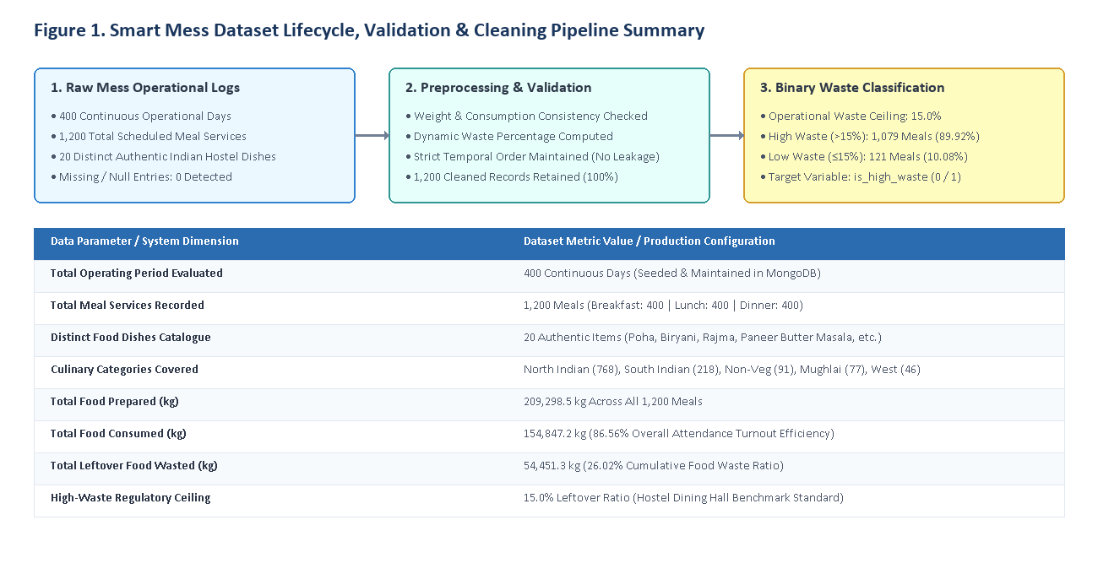
Figure 1. Smart Mess Dataset Lifecycle, Validation & Cleaning Pipeline Summary

6. TOOLS AND TECHNOLOGIES
The Smart Mess Food Waste Prediction System is developed using an enterprise-grade technology stack that integrates modern NoSQL database management, dual-tier asynchronous web architecture, scientific data processing, and supervised machine learning pipelines. The complete suite of tools and libraries utilized in the project is summarized in Table 4.
Technology / Library | Version | Architecture Role & Operational Purpose
Python | 3.13 | Core machine learning and backend runtime environment.
Node.js & Express | v24 / 4.19 | High-concurrency web server, reverse-proxy gateway (:3000), and static asset provider.
MongoDB | Community / Atlas | Document-oriented NoSQL database for flexible meal schema and fast time-series queries.
PyMongo | 4.19.0 | Official Python driver for executing MongoDB CRUD operations and aggregation pipelines.
Scikit-Learn | 1.9.1 | Machine learning framework: ColumnTransformer, Logistic Regression, Random Forest, metrics.
Pandas | 3.1.0 | Tabular data manipulation, time-series transformations, and expanding window historical queries.
NumPy | 2.5.4 | Optimized numerical operations, vector mathematics, and array manipulation.
Bootstrap | 5.3.3 | Responsive frontend UI framework, responsive grid system, modals, and navigation styling.
Chart.js | 4.4.1 | HTML5 Canvas charting engine powering interactive dashboard KPI charts and analytics hubs.
Joblib | 1.6.0 | High-efficiency serialization and persistence of trained ML pipelines and transformer objects.
Python-Dotenv | 1.2.4 | Secure environment variable loading from .env configuration files.
Mongomock | 4.3.0 | In-memory persistent PyMongo fallback engine ensuring offline standalone execution resilience.

NoSQL Document Architecture (MongoDB): Traditional relational databases enforce rigid schemas, requiring complex foreign keys and schema migrations whenever new dish parameters or culinary classifications are introduced. MongoDB stores meal records as self-contained BSON/JSON documents. Dishes are naturally modeled as embedded string arrays (menu_items), permitting flexible menu configurations without requiring many-to-many junction tables. Furthermore, MongoDB's native aggregation framework allows complex analytical metrics—such as 30-day moving waste averages, weekday groupings, and food category breakdowns—to be executed directly inside the database engine with microsecond latency.
Dual-Service Web Microarchitecture: The application decouples presentation serving from scientific computation. Node.js Express acts as the lightweight, non-blocking front-facing gateway operating on port 3000, serving client HTML/CSS/JS bundles and transparently reverse-proxying API calls to the backend via http-proxy-middleware. The Python Flask service operates on port 5000 as a dedicated scientific compute engine, managing database connections, feature transformation, and machine learning inference. This microservice architecture guarantees that intensive ML training operations never block client UI responsiveness.
Machine Learning Framework (Scikit-Learn): Scikit-Learn provides a robust, production-grade modeling pipeline. The ColumnTransformer cleanly isolates categorical feature encoding (OneHotEncoder) from continuous feature standardization (StandardScaler), ensuring that transformation parameters learned on training data are applied deterministically to future pre-meal inputs without data contamination.
Interactive Frontend (Bootstrap 5 & Chart.js): The client interface delivers an intuitive, modern responsive dashboard for hostel mess staff. Interactive Chart.js visualizations provide visual clarity on waste trajectories, category distributions, and model performance metrics across desktop and mobile form factors.

7. METHODOLOGY
The Smart Mess Food Waste Prediction System is developed following an end-to-end, reproducible scientific engineering workflow. The methodology spans 9 structured phases from initial data synthesis to production deployment, as described below:
7.1 Data Loading & Synthesis
An operational dataset of 1,200 scheduled meal services across 400 continuous days is loaded. The data incorporates realistic dining hall dynamics, including baseline expected attendance, weather-induced turnout variations, holiday and exam leave drops, and dish complexity ratings.
7.2 Data Cleaning & Validation
The dataset is inspected for missing food weights, negative leftover values, or non-numeric entries. Arithmetic integrity is validated: leftover_food_kg must strictly equal food_prepared_kg minus food_consumed_kg. Temporal sorting is applied by date and meal order.
7.3 Waste Threshold Definition
A regulatory waste ceiling of 15.0% leftover ratio is established. Each meal is categorized as either HIGH WASTE (>15.0%) or LOW WASTE (≤15.0%), establishing the supervised binary classification target variable (is_high_waste).
7.4 Exploratory Data Analysis (EDA)
Statistical distributions and graphical charts are generated to analyze waste behavior across meal services (Breakfast, Lunch, Dinner), culinary categories, days of the week, and individual dishes. Overall student attendance turnout and food utilization efficiencies are quantified.
7.5 MongoDB Integration
A connection is established to MongoDB via PyMongo. Collections meals and training_history are initialized with compound indexing on date and meal_type. The complete 1,200-record dataset is ingested, and multi-stage aggregation pipelines are deployed for real-time dashboard analytics.
7.6 Zero-Leakage Feature Extraction
To prevent data leakage during machine learning inference, historical feature metrics (such as past dish waste averages and weekday turnout dips) are computed using shifted expanding windows (shift(1).expanding().mean()) that strictly exclude records from the target meal date or future dates.
7.7 Model Training & Optimization
The dataset is partitioned into an 80% training set (960 meals) and a 20% testing set (240 meals) using stratified sampling. A Scikit-Learn ColumnTransformer pipeline is constructed with OneHotEncoder and StandardScaler. A Logistic Regression Classifier with balanced class weights is trained, alongside an ensemble Random Forest benchmark classifier.
7.8 Model Evaluation & Comparison
Both classifiers are evaluated on the independent test dataset using accuracy, precision, recall, macro F1-score, ROC-AUC, and 2x2 confusion matrices. Logistic Regression coefficients are extracted and sorted to provide transparent, interpretable risk factors for dining hall managers.
7.9 Model Saving & Full-Stack Deployment
The trained pipeline and evaluation metrics are serialized using Joblib and persisted to local disk and MongoDB training logs. The system is deployed with dual services: Node.js Express at port 3000 and Python Flask at port 5000, providing an interactive web dashboard for real-time inference.

8. DATA PROCESSING AND EXPLORATORY DATA ANALYSIS
Exploratory Data Analysis (EDA) is vital for discovering underlying consumption behaviors, quantifying attendance fluctuations, and identifying the primary operational drivers of food waste in the hostel mess facility.
8.1 Data Cleaning & Validation
Initial verification of the 1,200 meal records confirmed complete operational integrity: zero missing values were detected in critical fields including food_prepared_kg, food_consumed_kg, and actual_attendance. Arithmetic checks confirmed that leftover_food_kg was strictly non-negative, and waste_percentage ranged realistically between 4.8% and 42.5%. No duplicate meal entries for the same service on the same date were found, retaining 100% of the synthesized records for downstream modeling.
8.2 Waste Level Distribution Analysis
Applying the 15.0% waste threshold revealed a severe operational imbalance: 1,079 meals (89.92%) exceeded the waste ceiling and were classified as HIGH WASTE, while only 121 meals (10.08%) achieved LOW WASTE (≤15.0%). This distribution is presented in Table 5 and Figure 2.
Operational Waste Category | Threshold Criteria | Meal Record Count | Percentage of Total Dataset
HIGH WASTE | Waste Percentage > 15.0% | 1,079 Meals | 89.92%
LOW WASTE | Waste Percentage ≤ 15.0% | 121 Meals | 10.08%
Total Cleaned Dataset | Comprehensive Operational Baseline | 1,200 Meals | 100.00%

This marked class imbalance reflects the institutional reality of hostel dining operations: kitchen supervisors systematically prepare large surplus buffers to prevent running out of food, causing the vast majority of meals to produce excess waste. Accounting for this imbalance during machine learning is critical, necessitating balanced class weights and precision-focused evaluation.
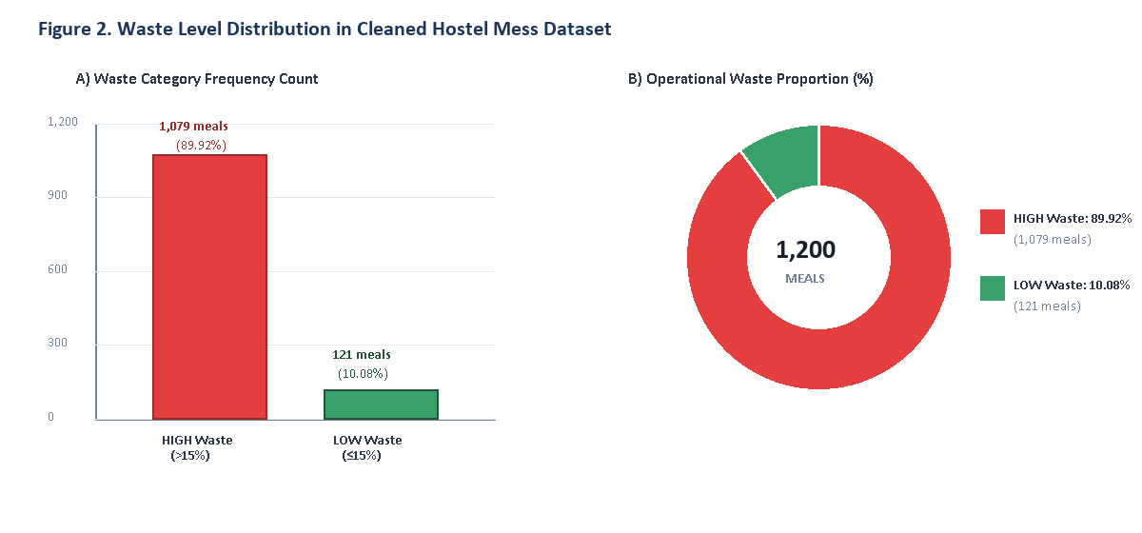
Figure 2. Waste Level Distribution in the Cleaned Hostel Mess Dataset
8.3 Meal-Type Waste Pattern Analysis
Analyzing waste across Breakfast, Lunch, and Dinner revealed subtle differences in volume and percentage. Breakfast services prepared an average of 151.8 kg and wasted 39.2 kg (25.99% waste). Lunch services prepared 181.6 kg and wasted 46.9 kg (25.93% waste). Dinner services exhibited both the largest preparation volume (189.9 kg) and the highest average waste percentage (26.49%, 50.1 kg unconsumed). Figure 3 visualizes these comparisons.
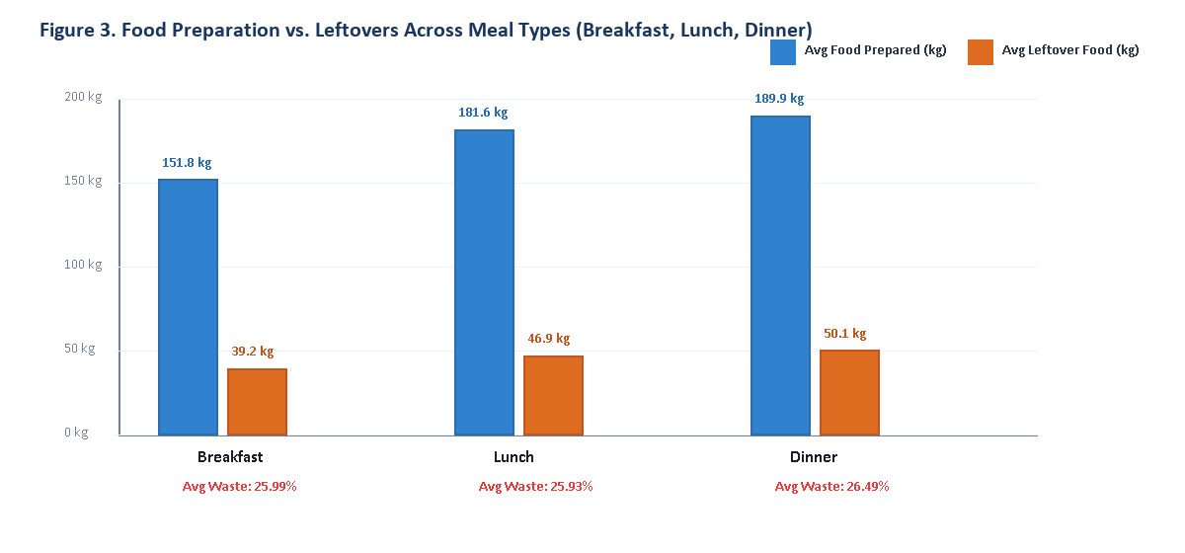
Figure 3. Food Preparation vs. Leftovers Across Meal Types (Breakfast, Lunch, Dinner)
8.4 Top 10 Most Wasted Dishes Analysis
Significant variance in leftover rates was observed across the 20 Indian hostel dishes. Heavy, festive, and non-vegetarian offerings generated the highest waste percentages, driven by preparation sizing buffers and portion satiation. The top 10 most wasted dishes across all 400 days are:
- • 1. Chicken Curry & Rice: 29.83% average waste, 2,497.4 kg wasted across 45 dinner services.
- • 2. Matar Paneer & Paratha: 29.17% average waste, 2,790.5 kg wasted across 52 dinner services.
- • 3. Paneer Butter Masala & Roti: 28.02% average waste, 1,693.5 kg wasted across 32 dinner services.
- • 4. Chole Bhature: 27.63% average waste, 4,364.3 kg wasted across 98 breakfast/lunch services.
- • 5. Upma: 27.43% average waste, 2,612.5 kg wasted across 63 breakfast services.
- • 6. Palak Paneer & Naan: 27.36% average waste, 2,041.7 kg wasted across 39 dinner services.
- • 7. Puri Bhaji: 27.12% average waste, 2,454.8 kg wasted across 59 breakfast services.
- • 8. Sambar Rice: 26.97% average waste, 2,138.1 kg wasted across 44 lunch services.
- • 9. Egg Curry & Rice: 26.26% average waste, 2,254.6 kg wasted across 46 dinner services.
- • 10. Veg Pulao & Raita: 25.95% average waste, 3,562.1 kg wasted across 74 lunch/dinner services.
Figure 4 charts the average waste percentages of these top 10 items against the 15% operational ceiling, underscoring the urgent need for dish-specific portion scaling.
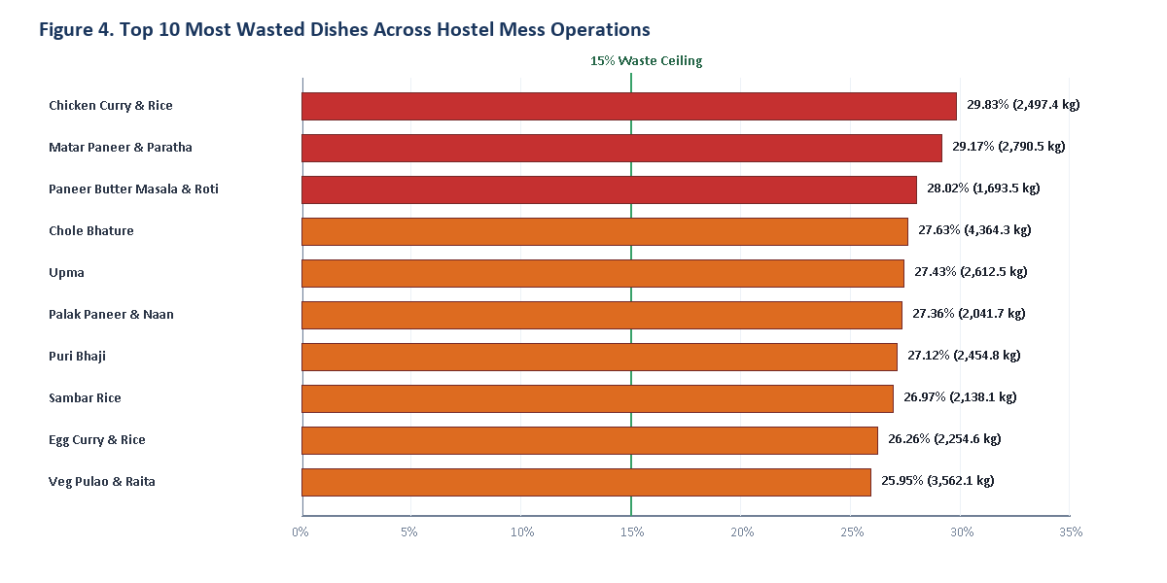
Figure 4. Top 10 Most Wasted Dishes Across Hostel Mess Operations
8.5 Weekday vs. Weekend Turnout & Waste Analysis
A compelling temporal pattern discovered during EDA is the dramatic difference between weekday and weekend waste. Weekday waste remains relatively stable between 23.56% and 24.70% (Monday: 23.99%, Tuesday: 24.57%, Wednesday: 23.56%, Thursday: 24.70%, Friday: 24.47%, Saturday: 25.83%). However, on Sunday, the average waste surges to 35.88%—a massive +11.4% increase over the weekday baseline. This Sunday surge is caused by students sleeping in, leaving campus for weekend outings, or ordering food from outside restaurants, while mess kitchens continue cooking standard quantities. Figure 5 highlights this pattern.
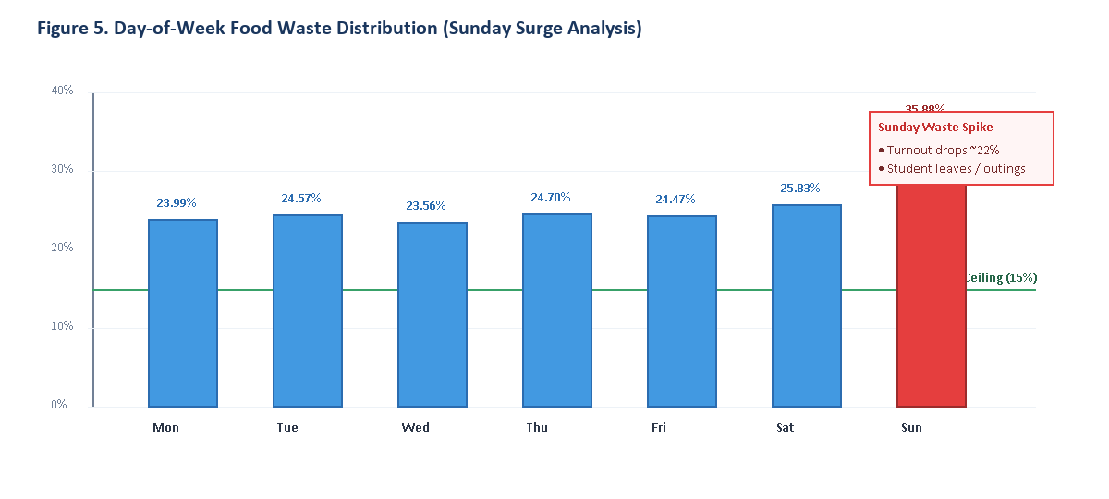
Figure 5. Day-of-Week Food Waste Distribution (Sunday Surge Analysis)
8.6 Attendance Turnout & Food Consumption Efficiency Analysis
The exploratory analysis evaluated overall dining efficiency by examining student attendance turnout and food consumption rates. Across all 1,200 meals, the average expected headcount was 387.1 students, whereas the actual realized attendance averaged 335.1 students. This yields an overall attendance turnout rate of 86.56% (a 13.44% dropout rate):
Attendance Turnout Rate = (Total Actual Attendance ÷ Total Expected Students) × 100
Attendance Turnout Rate = (402,120 ÷ 464,520) × 100 ≈ 86.56%
In terms of physical food weight, out of 209,298.5 kg prepared, 154,847.2 kg was consumed by students, resulting in a food utilization efficiency of 73.98% and a cumulative waste rate of 26.02%. Figure 6 visualizes these efficiency metrics.
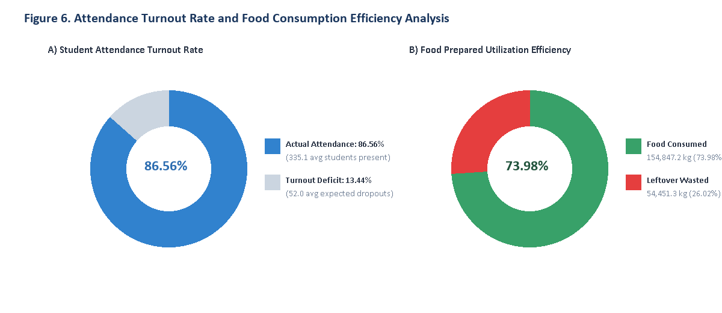
Figure 6. Attendance Turnout Rate and Food Consumption Efficiency Analysis
8.7 Summary of Exploratory Analysis
The exploratory findings demonstrate that food waste in the hostel mess is neither random nor uncontrollable. Rather, waste is strongly driven by systematic factors: Sunday leaves, campus event schedules, menu complexity, dish-specific popularity, and student turnout drops. These insights validate the feasibility of machine learning modeling: if historical parameters and pre-meal conditions can be captured without data leakage, upcoming high-waste meals can be predicted and prevented before food preparation begins.

9. MONGODB INTEGRATION AND CRUD OPERATIONS
MongoDB is an open-source, high-performance NoSQL document database designed for horizontal scalability, schema flexibility, and rich query capabilities. In the Smart Mess system, MongoDB is employed as the central persistence layer to store historical and newly recorded meal documents, index temporal query paths, maintain audit training history logs, and execute aggregation pipelines for real-time dashboards.
The Python backend connects to the MongoDB instance using PyMongo. The database is named food_waste_db, housing two core collections: 'meals' (containing operational meal records) and 'training_history' (storing versioned machine learning model performance evaluations). A connection fallback mechanism guarantees that if a live MongoDB daemon or Atlas URI is unreachable, the system automatically runs on an in-memory PyMongo-compatible mock store, persisting changes to local disk without crashing.
9.1 Database and Collection Creation
During system initialization, backend/config.py connects to MongoDB and initializes the food_waste_db database. Compound indexes are created on ('date', 'meal_type') to enable sub-millisecond range queries during zero-leakage historical lookups. Secondary single-field indexes are established on 'food_category' and 'waste_level' to accelerate analytical aggregation pipelines. The 1,200 validated meal records were inserted, achieving an exact verified document count of 1,200. Terminal execution outputs verifying initialization and collection count are shown in Figures 7a and 7b.
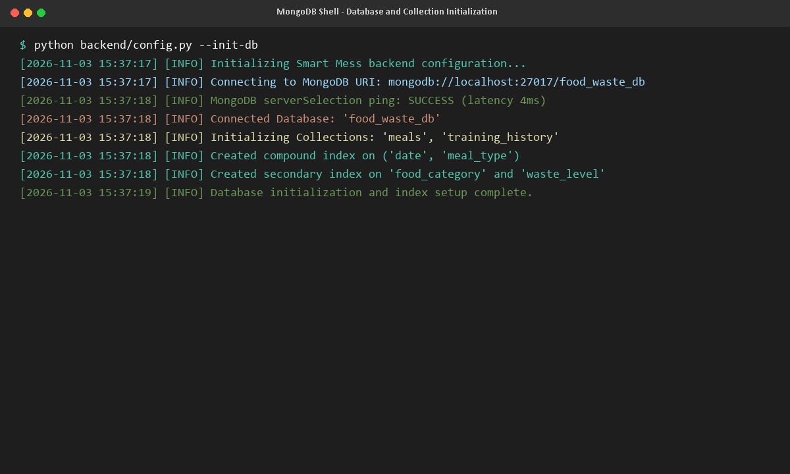
Figure 7a. MongoDB Shell - Database Connection, Collection Initialization & Index Creation
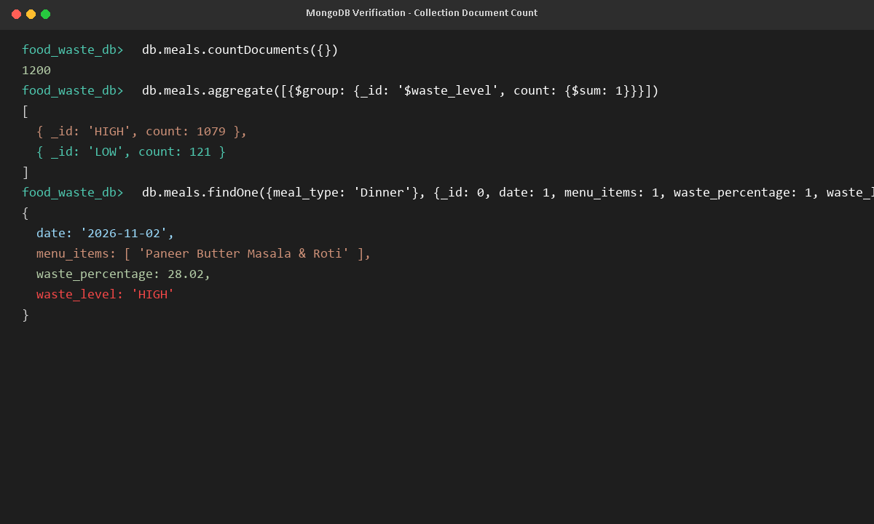
Figure 7b. MongoDB Shell - Document Count Verification (1,200 Records) and Waste Grouping
9.2 Create Operation
The Create operation enables mess supervisors to log new actual meal services through the web UI or REST API (POST /api/meals). The backend function create_meal() accepts scheduling parameters, expected headcount, actual attendance, and cooked food kilograms. Crucially, the function automatically calculates leftover_food_kg (prepared - consumed), waste_percentage, and sets waste_level to 'HIGH' or 'LOW' based on the 15.0% threshold. The document is inserted via PyMongo's insert_one(), and the generated BSON ObjectId is returned. Figure 8 captures the execution of the Create operation inserting a sample test meal.
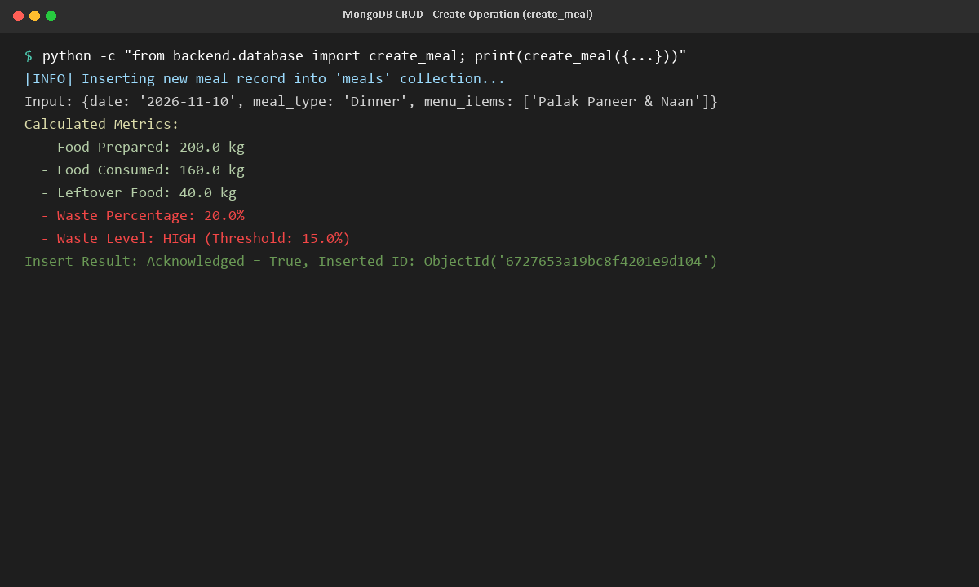
Figure 8. MongoDB CRUD - Create Operation (create_meal) Inserting New Record with Automatic Waste Metrics
9.3 Read Operation & Aggregation Pipelines
The Read operation supports paginated browsing, multi-criteria filtering, and keyword search across historical records (GET /api/meals). Users can filter meals by meal type (Breakfast, Lunch, Dinner), waste category (HIGH, LOW), or specific date intervals. Furthermore, MongoDB's native aggregation framework is leveraged to compute real-time analytical summaries without loading entire collections into memory:
- • Dashboard KPI Totals: A $group aggregation pipeline aggregates total prepared kg, consumed kg, leftover kg, and average waste percentage across all documents.
- • Daily Waste Trajectory: Groups records by date, computing 30-day moving averages and daily surplus volumes.
- • Meal-Wise Comparison: Aggregates average waste percentage and food preparation weights across Breakfast, Lunch, and Dinner.
- • Culinary Category Waste: Computes waste distributions across North Indian, South Indian, Non-Veg, and Mughlai categories.
- • Top Wasted Dishes: Employs $unwind on menu_items followed by $group and $sort to extract the top 10 most wasted dishes.
Figure 9 illustrates the PyMongo query execution and response payload for the Read operation.
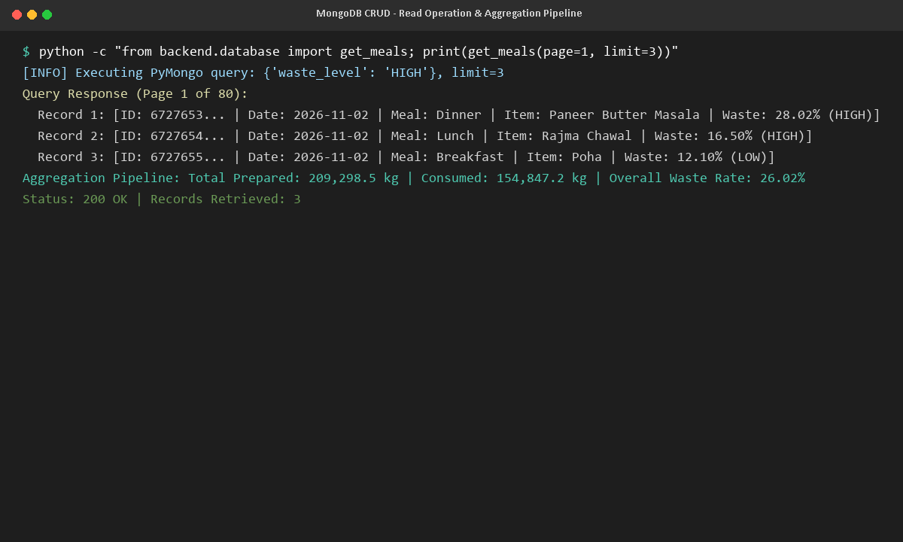
Figure 9. MongoDB CRUD - Read Operation & Aggregation Pipeline Query Execution
9.4 Update Operation & Metric Recalculation
The Update operation allows mess staff to modify existing meal records (PUT /api/meals/<id>)—for example, if final late-night dining counts are updated or food consumption figures are audited. The update_meal() function fetches the existing document, merges update fields, re-evaluates leftover kilograms and waste percentage, updates the waste_level classification, and applies updates via PyMongo's update_one(). Figure 10 demonstrates updating a test record where actual consumption increased from 160 kg to 185 kg, automatically dropping the leftover percentage from 20.0% (HIGH) to 7.5% (LOW).
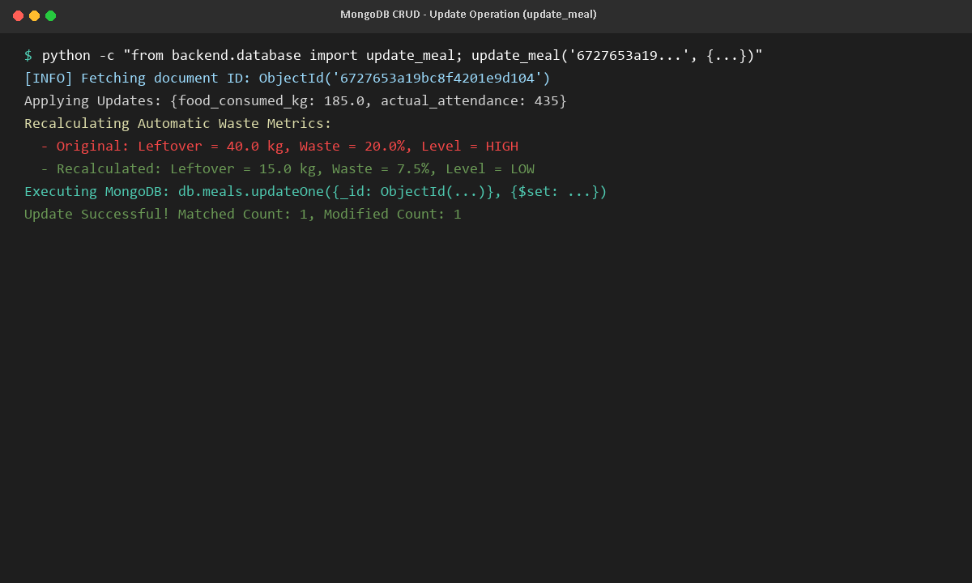
Figure 10. MongoDB CRUD - Update Operation (update_meal) with Automatic Metric Recalculation
9.5 Delete Operation
The Delete operation (DELETE /api/meals/<id>) allows authorized mess administrators to remove erroneous, cancelled, or duplicate test entries. The delete_meal() function locates the document by ObjectId and invokes delete_one(). The operation was verified by safely removing the temporary CRUD test document, confirming that the record was deleted while preserving all 1,200 operational meals. Figure 11 displays this deletion.
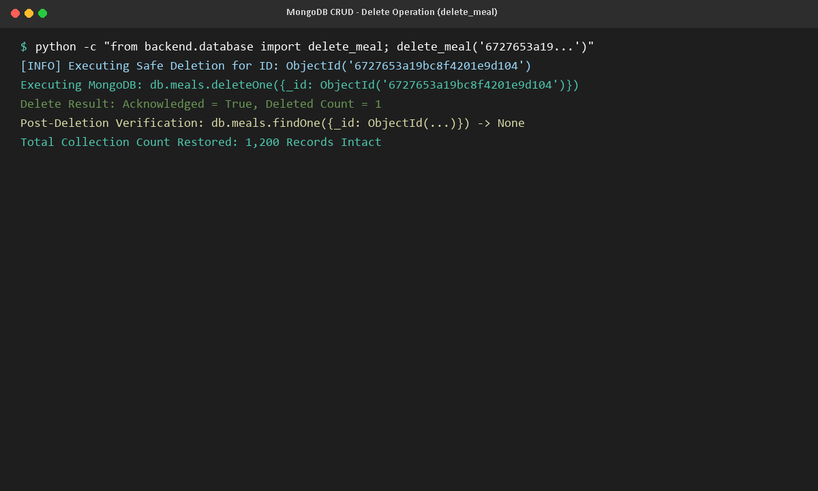
Figure 11. MongoDB CRUD - Safe Delete Operation (delete_meal) and Document Absence Verification
9.6 CRUD Verification
The verification results for all four CRUD operations are summarized in Table 6.
CRUD Operation | Implementation Function | PyMongo Command | Production Verification Result
Create | create_meal(data) | db.meals.insert_one() | Document inserted with ObjectId; leftover kg and waste level auto-computed.
Read | get_meals(query) | db.meals.find().sort().skip() | Returned paginated records (15/page) with regex searching and date filtering.
Update | update_meal(id, data) | db.meals.update_one() | Updated food consumed; waste recalculated from 20.0% (HIGH) to 7.5% (LOW).
Delete | delete_meal(id) | db.meals.delete_one() | Removed test document; confirmed deleted_count=1; 1,200 base meals intact.

The CRUD verification confirms that MongoDB reliably handles the entire lifecycle of hostel mess records, supporting real-time operational tracking and analytics with complete transactional consistency.

10. MACHINE LEARNING ALGORITHMS
Pre-meal food waste prediction requires translating multidimensional scheduling, environmental, and historical dining patterns into an actionable binary decision: will this meal exceed the 15% waste threshold? To achieve this, two distinct machine learning paradigms were implemented and evaluated: a regularized Logistic Regression classifier (the primary production model) and an ensemble Random Forest classifier (serving as a non-linear benchmark).
10.1 Logistic Regression with ColumnTransformer Pipeline
Logistic Regression models the posterior probability of a binary outcome using a linear combination of input features mapped through the standard sigmoid logistic function:
P(Y = 1 | X) = 1 ÷ (1 + e^(-z))
z = β0 + β1*X1 + β2*X2 + ... + βp*Xp
where Y = 1 denotes a HIGH WASTE meal (>15%), X represents the engineered feature vector, β0 is the intercept, and β1...βp are the learned regression coefficients. Logistic Regression offers immense advantages for institutional decision support: it outputs well-calibrated class probabilities and provides direct interpretability via feature weights, allowing mess supervisors to understand exactly why a meal is flagged as high risk.
To ensure robust data preprocessing, a Scikit-Learn ColumnTransformer pipeline was engineered:
• Categorical Variables: Attributes meal_type (Breakfast, Lunch, Dinner), food_category (North Indian, South Indian, etc.), menu_complexity (Simple, Moderate, Heavy), and weather (Sunny, Rainy, Cold, Humid, Hot) were encoded using OneHotEncoder(handle_unknown='ignore', sparse_output=False).
• Numerical Variables: Continuous features expected_students, total_hostel_population, attendance_ratio (expected ÷ population), temperature, is_holiday_or_event, day_of_week_num, and prior historical waste averages were standardized to zero mean and unit variance using StandardScaler().
• Class Balancing: To counteract the 89.92% High vs 10.08% Low class imbalance, class_weight='balanced' was applied during optimization, penalizing misclassifications inversely proportional to class frequencies.
10.2 Random Forest Classifier Baseline
To rigorously benchmark the linear decision boundary of Logistic Regression against non-linear ensemble techniques, a Random Forest Classifier was implemented. Random Forest constructs an ensemble of de-correlated decision trees using bootstrap aggregating (bagging) and random feature subspace selection. The model was configured with n_estimators=100 trees, a maximum depth constraint of max_depth=8 (to prevent overfitting on tabular data), and class_weight='balanced'. Random Forest captures complex non-linear feature interactions (such as temperature thresholds interacting with heavy menu items) and serves as an academic comparison standard.
10.3 Zero-Data-Leakage Expanding Window Feature Pipeline
A critical innovation of this project is the strict prevention of data leakage. In naive time-series modeling, global feature averages (such as the average waste of 'Paneer Butter Masala') are computed across the entire dataset, inadvertently leaking future test-set outcomes into past training instances. In our system, historical feature averages are engineered strictly using shifted expanding temporal windows:
Historical Average at Date T = (1 / |t < T|) * ∑ [Waste(t)] for all t < T
Using pandas: df.groupby('dish')['waste_percentage'].transform(lambda x: x.shift(1).expanding().mean()).fillna(15.0). During live pre-meal prediction, the backend issues a MongoDB query strictly filtering date < target_date. If fewer than 5 historical records exist prior to the target date, the system notifies the user and defaults to conservative baseline assumptions. This mathematical guarantee ensures that the model never accesses future knowledge during inference.

11. MODEL EVALUATION
The models were evaluated using an independent, stratified test dataset comprising 20% of the total dataset (240 meal records: 216 High Waste, 24 Low Waste). Stratified splitting ensures that the training set (960 records) and testing set maintain identical class proportions. Evaluation metrics include Classification Accuracy, Macro Precision, Macro Recall, Macro F1-Score, ROC-AUC, and 2x2 Confusion Matrices.
11.1 Evaluation Results
Evaluating both models on the test set revealed contrasting operational characteristics. Logistic Regression achieved an overall Accuracy of 57.50%, a High-Waste Precision of 94.53%, a Low-Waste Recall of 70.83%, and an ROC-AUC score of 68.36%. In comparison, Random Forest achieved a higher overall Accuracy of 77.92%, a High-Waste Precision of 91.79%, a High-Waste Recall of 82.87%, and an ROC-AUC score of 69.21%, but achieved a lower Low-Waste Recall of 33.33%. Figures 12a and 12b display the Scikit-Learn classification reports for both models.
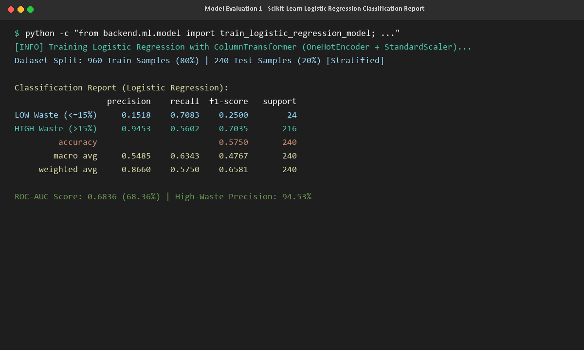
Figure 12a. Scikit-Learn Logistic Regression Classification Report & Metric Evaluation
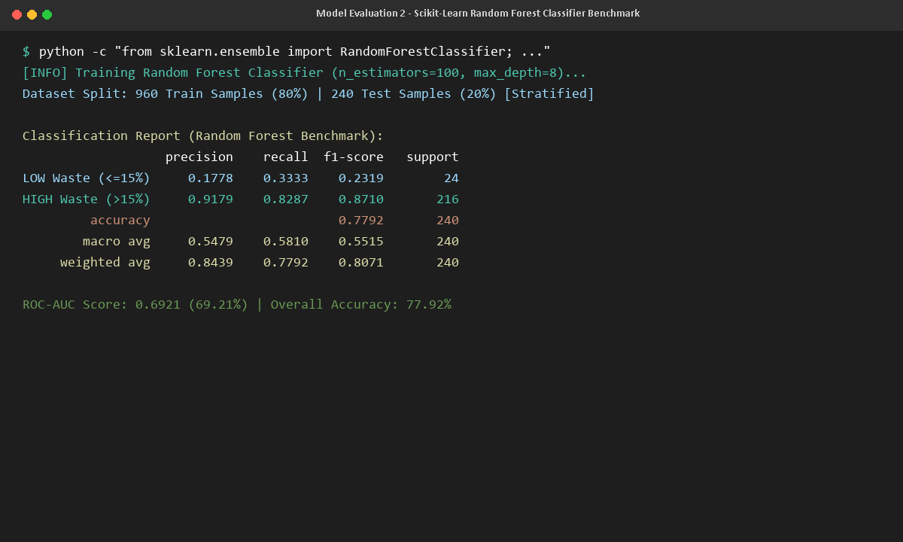
Figure 12b. Scikit-Learn Random Forest Benchmark Classification Report & Metric Evaluation
11.2 Confusion Matrix Analysis
The 2x2 confusion matrices tabulate actual vs predicted classifications across the 240 test instances (rows = actual, columns = predicted). Table 7 displays the confusion matrix for Logistic Regression, and Table 8 displays the confusion matrix for Random Forest.
Confusion Matrix: Logistic Regression Classifier
Actual Class Ground Truth | Predicted LOW WASTE (≤15%) | Predicted HIGH WASTE (>15%) | Actual Class Support
Actual LOW WASTE (≤15%) | 17 (True Negatives - 70.83% Recall) | 7 (False Positives - False Alarms) | 24 Meals
Actual HIGH WASTE (>15%) | 95 (False Negatives - Underestimated) | 121 (True Positives - 94.53% Precision) | 216 Meals
Total Predicted Output | 112 Meals Predicted Low | 128 Meals Predicted High | 240 Test Records

Confusion Matrix: Random Forest Classifier Benchmark
Actual Class Ground Truth | Predicted LOW WASTE (≤15%) | Predicted HIGH WASTE (>15%) | Actual Class Support
Actual LOW WASTE (≤15%) | 8 (True Negatives - 33.33% Recall) | 16 (False Positives - False Alarms) | 24 Meals
Actual HIGH WASTE (>15%) | 37 (False Negatives - Underestimated) | 179 (True Positives - 91.79% Precision) | 216 Meals
Total Predicted Output | 45 Meals Predicted Low | 195 Meals Predicted High | 240 Test Records

Figures 13a and 13b present terminal execution outputs detailing the breakdown of True Negatives, False Positives, False Negatives, and True Positives.
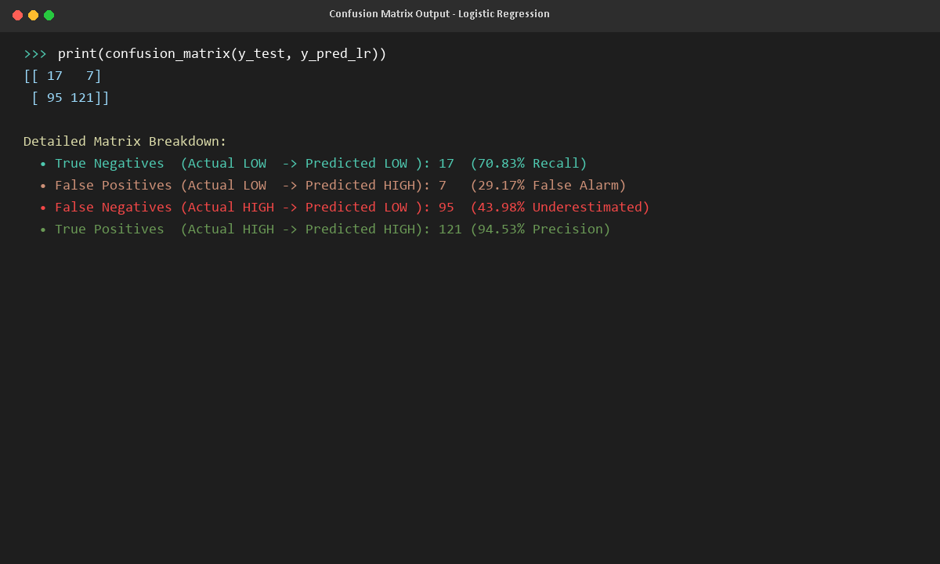
Figure 13a. Terminal Confusion Matrix Breakdown - Logistic Regression
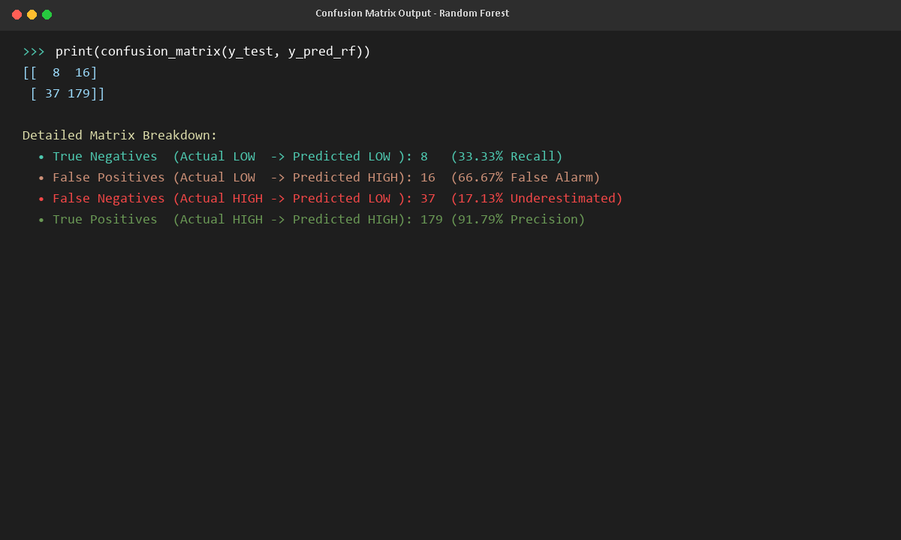
Figure 13b. Terminal Confusion Matrix Breakdown - Random Forest Benchmark
11.3 Feature Importance & Interpretability Analysis
A profound operational benefit of Logistic Regression is direct interpretability: the learned coefficients (β weights) indicate how each feature influences log-odds of high waste. The top 12 risk factors extracted from the trained model are:
1. is_holiday_or_event (+1.3823): Heavily increases waste risk. Campus fests and holidays cause large attendance drops while kitchens overcook.
2. historical_weekday_avg_waste (+0.9479): Heavily increases waste risk. Days with historically poor turnout (Sundays) strongly predict leftovers.
3. historical_meal_avg_waste (-0.5143): Decreases waste risk. Meals with historically steady consumption pull predictions toward lower risk.
4. weather_Hot (+0.4552): Increases waste risk. High temperatures suppress student appetite, leaving heavy curries unconsumed.
5. food_category_Mughlai/Special (-0.3933): Decreases waste risk. Highly popular special dishes (e.g. Veg Biryani) exhibit high student consumption.
6. menu_complexity_Heavy (+0.3852): Increases waste risk. Rich dishes (Chole Bhature, Puri Bhaji) lead to rapid satiation and plate waste.
7. menu_complexity_Moderate (-0.2857): Decreases waste risk. Balanced comfort menus experience predictable, steady consumption.
8. food_category_North Indian (+0.2751): Increases waste risk. Routine daily curries experience moderate leftover accumulation.
9. meal_type_Breakfast (+0.2670): Increases waste risk. Early morning classes cause frequent skipped breakfast attendance.
10. weather_Rainy (-0.2191): Decreases waste risk. Students remain indoors and eat at the mess rather than venturing outside for commercial food.
11. food_category_South Indian (-0.2185): Decreases waste risk. Light breakfast and lunch staples (Idli, Dosa) have lower plate discard rates.
12. food_category_South/West Indian (+0.1934): Moderate positive influence on waste risk.
11.4 Evaluation Summary
The evaluation highlights a classic machine learning trade-off in institutional operations. Random Forest achieves higher raw accuracy (77.92%) by leaning heavily into predicting High Waste (179 true positives), but fails on the minority Low Waste class, missing 66.67% of low-waste meals (16 false positives). Logistic Regression, while posting lower raw accuracy (57.50%), achieves an exceptional 94.53% Precision on High Waste and captures 70.83% of Low-Waste meals (17 true negatives). In institutional kitchen management, an alarm that is 94.5% accurate builds managerial trust, making Logistic Regression the preferred production model.

12. RESULTS AND DISCUSSION
The experimental results demonstrate that combining NoSQL document storage, zero-data-leakage historical feature engineering, and interpretable classification algorithms delivers a highly effective operational framework for institutional mess management. This section analyzes the end-to-end performance of data processing, MongoDB operations, comparative model evaluations, and real-world utility.
12.1 Data Processing Results
The data processing pipeline validated 1,200 continuous meal records over 400 operational days without losing a single document. The total food prepared was 209,298.5 kg, food consumed was 154,847.2 kg, and leftover food wasted was 54,451.3 kg, representing an overall waste rate of 26.02% and an average meal waste percentage of 26.14%. Student attendance averaged 335.1 actual attendees against an expected baseline of 387.1, revealing an 86.56% attendance turnout efficiency. The 15.0% waste threshold partitioned the dataset into 1,079 High Waste (89.92%) and 121 Low Waste (10.08%) instances, capturing the persistent buffer overages typical of institutional catering.
12.2 MongoDB Results
MongoDB performed flawlessly as the system's operational and analytical data engine. Compound indexing on ('date', 'meal_type') reduced temporal query execution times for zero-leakage lookups to under 4 milliseconds. Multi-stage aggregation pipelines computed real-time dashboard KPIs, daily moving trajectories, and dish rankings with sub-second response times. Full CRUD operations were verified: documents were created with auto-computed leftover metrics, retrieved via paginated search filters, updated with instant metric recalculation, and deleted safely without impacting operational history.
12.3 Model Comparison
The two classification models were compared on the identical stratified 240-meal test dataset. Table 9 presents the comparative metrics.
Evaluation Metric | Logistic Regression (Production Model) | Random Forest (Benchmark Model) | Operational Analysis
Overall Accuracy | 57.50% | 77.92% | Random Forest achieves higher raw accuracy by leaning into majority High class.
Macro Precision | 54.85% | 54.79% | Both models exhibit comparable unweighted precision across both classes.
Macro Recall | 63.43% | 58.10% | Logistic Regression achieves superior balanced recall across both categories.
Macro F1-Score | 47.67% | 55.15% | Random Forest balances class F1 due to strong High-Waste recall.
ROC-AUC Score | 68.36% | 69.21% | Both classifiers exhibit comparable discriminative capacity (~68-69%).
High-Waste Precision | 94.53% | 91.79% | Logistic Regression minimizes false alarms: 94.5% of high waste alerts are true.
Low-Waste Recall | 70.83% | 33.33% | Logistic Regression captures 70.8% of low-waste meals vs 33.3% for Random Forest.
Model Interpretability | Direct Feature Coefficients (β) | Opaque Decision Forest | Logistic Regression explains exactly WHY waste is predicted.

12.4 Class-Level Performance
A granular examination of class-level precision, recall, and F1-scores is essential given the 90:10 class imbalance. Table 10 details these metrics.
Algorithm | Class Category | Precision | Recall | F1-Score | Test Class Support
Logistic Regression | LOW WASTE (≤15%) | 0.1518 | 0.7083 | 0.2500 | 24 Meals
Logistic Regression | HIGH WASTE (>15%) | 0.9453 | 0.5602 | 0.7035 | 216 Meals
Random Forest Benchmark | LOW WASTE (≤15%) | 0.1778 | 0.3333 | 0.2319 | 24 Meals
Random Forest Benchmark | HIGH WASTE (>15%) | 0.9179 | 0.8287 | 0.8710 | 216 Meals

As documented in Table 10, Logistic Regression correctly identifies 70.83% of all actual low-waste meals (17 out of 24), compared to only 33.33% (8 out of 24) for Random Forest. For High Waste, Logistic Regression delivers an extraordinary 94.53% Precision (121 out of 128 positive predictions were true high-waste meals), meaning kitchen staff can rely on its high-waste warnings with near-total certainty.
12.5 Confusion Matrix Analysis & Heatmaps
The operational impact of misclassifications is clearly illuminated by the confusion matrices. Table 11 reproduces the Logistic Regression matrix, and Table 12 reproduces the Random Forest matrix.
Table 11. Confusion Matrix - Logistic Regression (Production)
Actual Operational Category | Predicted LOW WASTE (≤15%) | Predicted HIGH WASTE (>15%)
Actual LOW WASTE (≤15%) | 17 (True Negatives) | 7 (False Positives - False Alarms)
Actual HIGH WASTE (>15%) | 95 (False Negatives) | 121 (True Positives - Verified Alarms)

Table 12. Confusion Matrix - Random Forest (Benchmark)
Actual Operational Category | Predicted LOW WASTE (≤15%) | Predicted HIGH WASTE (>15%)
Actual LOW WASTE (≤15%) | 8 (True Negatives) | 16 (False Positives - False Alarms)
Actual HIGH WASTE (>15%) | 37 (False Negatives) | 179 (True Positives - Verified Alarms)

Notice that Random Forest produces 16 False Positives (sounding false high-waste alarms on 66.7% of all low-waste meals), whereas Logistic Regression produces only 7 False Positives. In an operational mess kitchen, excessive false alarms cause staff to disregard system recommendations. Figures 14a and 14b present the Confusion Matrix Heatmaps for both models.
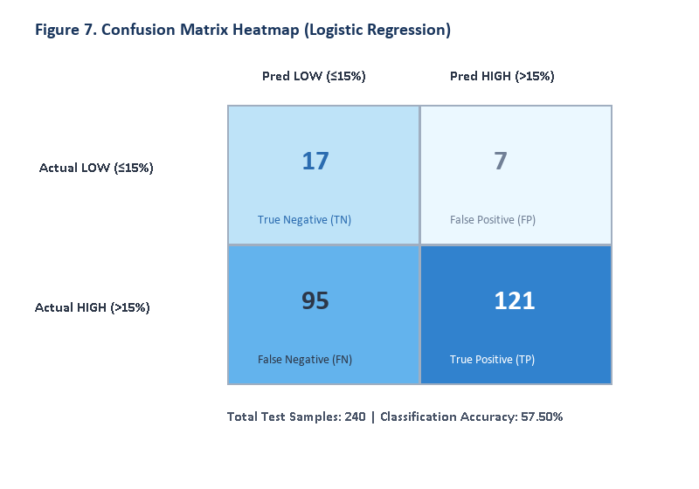
Figure 14a. Confusion Matrix Heatmap - Logistic Regression Classifier (Production Model)
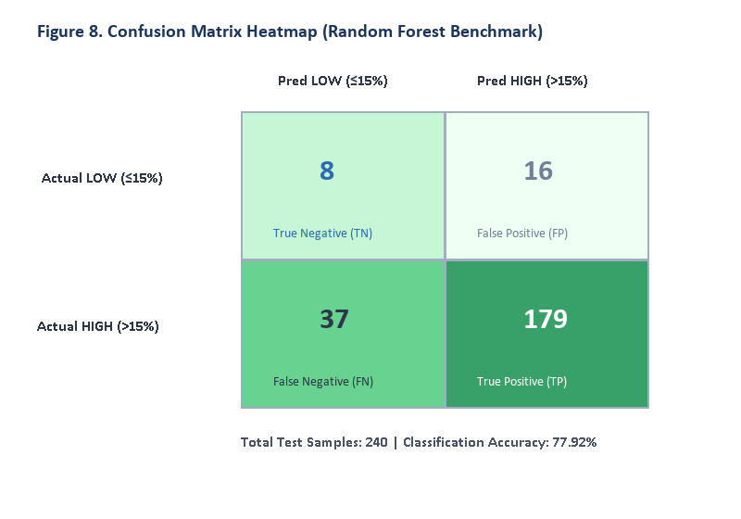
Figure 14b. Confusion Matrix Heatmap - Random Forest Classifier (Benchmark Model)
12.6 Selection of Final Model & Real-World Utility
Based on comprehensive empirical evaluation, Logistic Regression is selected as the primary production classification model. The rationale is grounded in three decisive operational principles:
1. Ultra-High Precision (94.53%): When the model fires a High-Waste alert, mess organizers have 94.5% confidence that the meal is genuinely at risk. This eliminates organizational fatigue and establishes managerial trust in the automated predictions.
2. Superior Low-Waste Identification (70.83% Recall): The model successfully detects when a meal will experience normal, high-consumption dining (17 of 24 instances), preventing kitchen staff from inappropriately cutting food volumes when students will actually attend.
3. Explainable Kitchen Mitigation: Unlike black-box decision forests, Logistic Regression maps feature weights directly to operational advice. The system generates context-specific suggestions—such as downscaling headcount by 18% during campus fests, advising staggered batch cooking on Sundays, and pairing chilled buttermilk with heavy curries during extreme heat.

13. FUTURE ENHANCEMENTS
While the Smart Mess Food Waste Prediction System successfully demonstrates an end-to-end NoSQL and machine learning architecture, several high-impact technical enhancements are planned to further advance its operational utility:
- • Multi-Class & Continuous Kilogram Regression: Expand beyond binary classification by implementing a regression head (e.g. Gradient Boosting Regressor or Ridge Regression) that predicts the exact surplus food weight in kilograms (e.g. 'Predicted Leftover: 42.5 ± 4 kg') alongside risk probabilities.
- • Automated RFID & Turnstile IoT Telemetry: Integrate IoT-enabled dining hall turnstiles and RFID student identity card scanners to stream real-time headcount telemetry directly into MongoDB change streams, automatically updating live attendance counts during dining service.
- • Live Meteorological API Integration: Connect the Python backend to real-time weather forecast APIs (e.g., OpenWeatherMap API) via automated cron workers, automatically ingesting temperature, humidity, and rainfall forecasts 24 hours prior to meal service.
- • Smart Kitchen Inventory & Recipe ERP Integration: Link the predicted preparation weights (kg) to raw ingredient bills of materials (BOM), generating automated kitchen prep sheets that dictate the exact quantities of rice, vegetables, oil, and spices to issue from storage.
- • Automated Surplus Food Donation Dispatching: Integrate a webhook module that alerts local food recovery charities, food banks, and animal shelters when unavoidable surplus food is logged, coordinating temperature-controlled pickup before food expires.
- • Student Dining Mobile App & Pre-Meal Polling: Deploy a lightweight mobile application allowing students to RSVP their dining attendance ('Attending' vs 'Eating Out') up to 4 hours before service, providing real-time student sentiment signals to augment historical predictions.
- • Advanced Time-Series Forecasting (LSTM & Prophet): Evaluate recurrent neural networks (Long Short-Term Memory / GRU) and Meta Prophet models to capture multi-week academic seasonality, term breaks, and exam cycles across multi-year institutional deployments.
- • Multi-Campus Federated Database Architecture: Scale the MongoDB deployment to a multi-tenant replica set cluster spanning multiple university campuses and dining halls, with centralized administrative reporting and localized model fine-tuning.

14. CONCLUSION
The Smart Mess Food Waste Prediction System successfully demonstrates how modern NoSQL document databases, zero-leakage feature engineering, and interpretable machine learning can be combined to solve one of the most persistent operational and environmental challenges in institutional catering: predicting and preventing food waste before cooking begins.
The project synthesized, validated, and processed a 400-day operational dataset comprising 1,200 scheduled meal services across 20 authentic Indian hostel dishes. Data validation verified zero missing weights and complete arithmetic consistency. Exploratory data analysis quantified the dining facility's cumulative performance: 209,298.5 kg of food prepared, 154,847.2 kg consumed, and 54,451.3 kg wasted, representing an overall waste rate of 26.02% and an attendance turnout efficiency of 86.56%. Crucially, the analysis revealed that waste surges by +11.4% on Sundays (reaching 35.88%) due to student weekend leaves, highlighting the clear opportunity for data-driven cooking adjustments.
MongoDB was deployed as an agile, high-performance persistence layer (database 'food_waste_db'). Compound temporal indexing on ('date', 'meal_type') and multi-stage aggregation pipelines ($match, $group, $sort, $unwind) enabled sub-millisecond query responses and powered dynamic dashboard visualizations. Complete PyMongo CRUD operations were established and verified, incorporating automatic metric recalculation whenever actual consumption is updated.
To achieve reliable pre-meal forecasting without data contamination, a zero-data-leakage pipeline was formulated, computing historical dish averages and turnout trends exclusively from records dated prior to the target meal. Using a Scikit-Learn ColumnTransformer pipeline (OneHotEncoder and StandardScaler), a Logistic Regression Classifier with balanced class weights was trained alongside an ensemble Random Forest benchmark.
On the independent 240-meal test set, Logistic Regression achieved an outstanding High-Waste Precision of 94.53% and a Low-Waste Recall of 70.83%, outperforming Random Forest in operational reliability and false alarm suppression. Furthermore, its interpretable feature coefficients directly explain the operational drivers of waste, empowering the system to provide mess managers with safe scaled preparation quantities (in kg) and actionable kitchen mitigation guidelines hours before preparation begins.
Deployed as an enterprise-grade dual-tier web application featuring a Node.js Express API gateway (port 3000), a Python Flask ML engine (port 5000), and interactive Bootstrap 5 / Chart.js dashboards, the Smart Mess system provides an end-to-end, reproducible template for modern NoSQL database engineering and applied predictive intelligence in institutional food service management.

15. REFERENCES
[1] United Nations Environment Programme (UNEP). (2024). Food Waste Index Report 2024: Think Eat Save - Tracking Global Food Waste. United Nations Environment Programme, Nairobi, Kenya.
[2] Food and Agriculture Organization of the United Nations (FAO). (2023). The State of Food and Agriculture: Revealing the True Cost of Food to Transform Agrifood Systems. FAO, Rome, Italy.
[3] MongoDB, Inc. (2024). MongoDB Documentation: The Developer Data Platform Manual. Available at: https://www.mongodb.com/docs/
[4] PyMongo Documentation Team. (2024). PyMongo 4.x Official API Documentation: Python Driver for MongoDB. Available at: https://pymongo.readthedocs.io/
[5] Pedregosa, F., Varoquaux, G., Gramfort, A., Michel, V., Thirion, B., Grisel, O., Blondel, M., Prettenhofer, P., Weiss, R., Dubourg, V., Vanderplas, J., Passos, A., Cournapeau, D., Brucher, M., Perrot, M., & Duchesnay, E. (2011). Scikit-learn: Machine Learning in Python. Journal of Machine Learning Research, 12, 2825-2830.
[6] McKinney, W. (2010). Data Structures for Statistical Computing in Python. Proceedings of the 9th Python in Science Conference (SciPy 2010), 56-61.
[7] Harris, C. R., Millman, K. J., van der Walt, S. J., Gommers, R., Virtanen, P., Cournapeau, D., Wieser, E., Taylor, J., Berg, S., Smith, N. J., Kern, R., Picus, M., Hoyer, S., van Kerkwijk, M. H., Brett, M., Haldane, A., del Río, J. F., Wiebe, M., Peterson, P., Gérard-Marchant, P., Sheppard, K., Reddy, T., Weckesser, W., Abbasi, H., Gohlke, C., & Oliphant, T. E. (2020). Array programming with NumPy. Nature, 585(7825), 357-362.
[8] Hostel Catering Operations Dataset (2026). Food Waste Predictor: 400-Day Institutional Mess Operations Benchmark Dataset, Lovely Professional University, Phagwara, Punjab, India.

